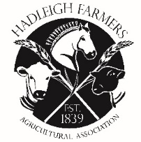 | HADLEIGH FARMERS' AGRICULTURAL ASSOCIATION  HORTICULTURAL CLASSES ENTRY FORM  HADLEIGH SHOW – SATURDAY 18th May 2024

Name
Address
Tel No
Email

Please tick classes you wish to enter.
Entries close – 7th May 2024

Class Number | Tick to enter
Class 1
Class 2
Class 3
Class 4
Class 5
Class 6
Class 7
Class 8
Class 9
Class 10
Class 11
Class 12
Class 13
Class 14
Class 15

Please return to: Mr. P Simpson, Wetherden Hall, Balls Hill, Hitcham, IP7 7PZ
Email: patrick.simpson1uk@gmail.com

